Week 3 - Day 4 - Postman CRUD Testing Results

1. GET All Books (200 OK)
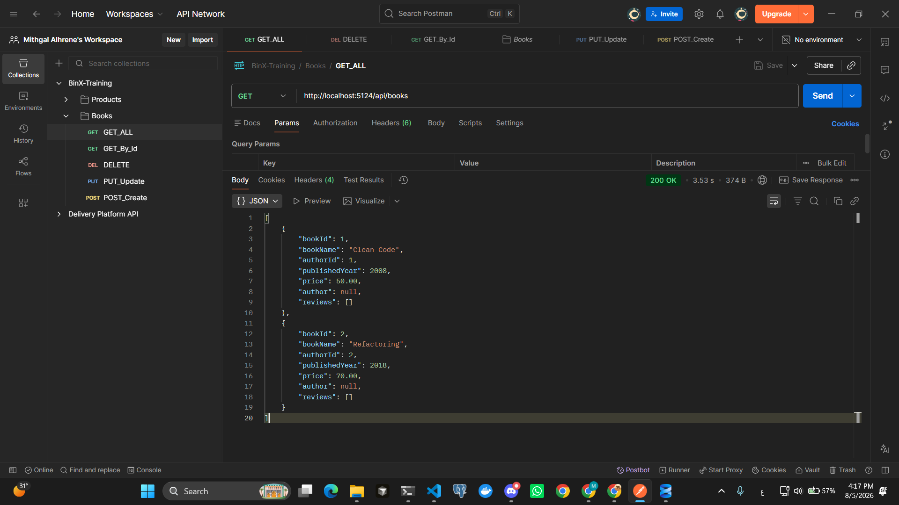

2. GET Book By ID (200 OK)
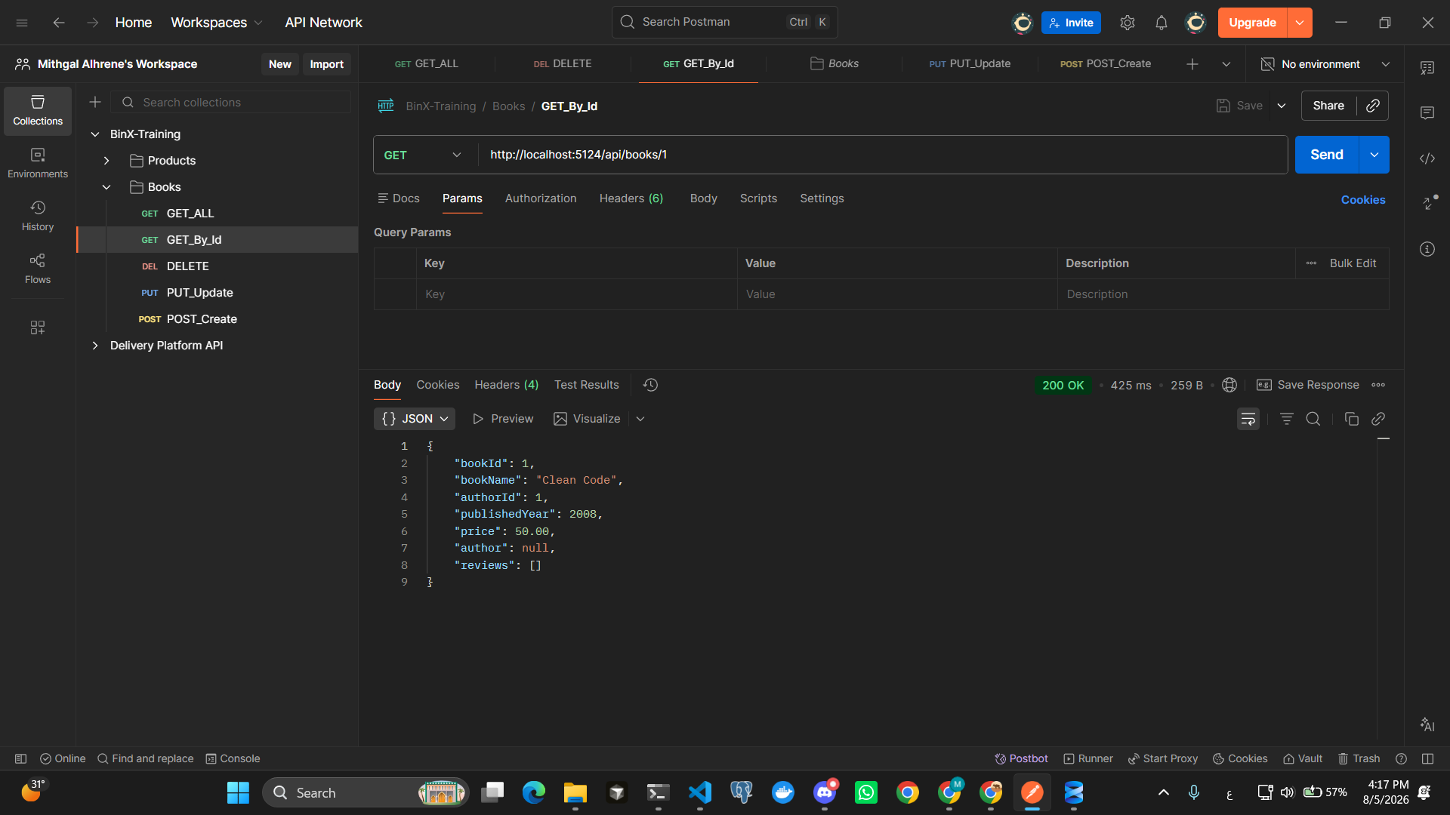

3. GET Book with Invalid ID (-1) (400 Bad Request)
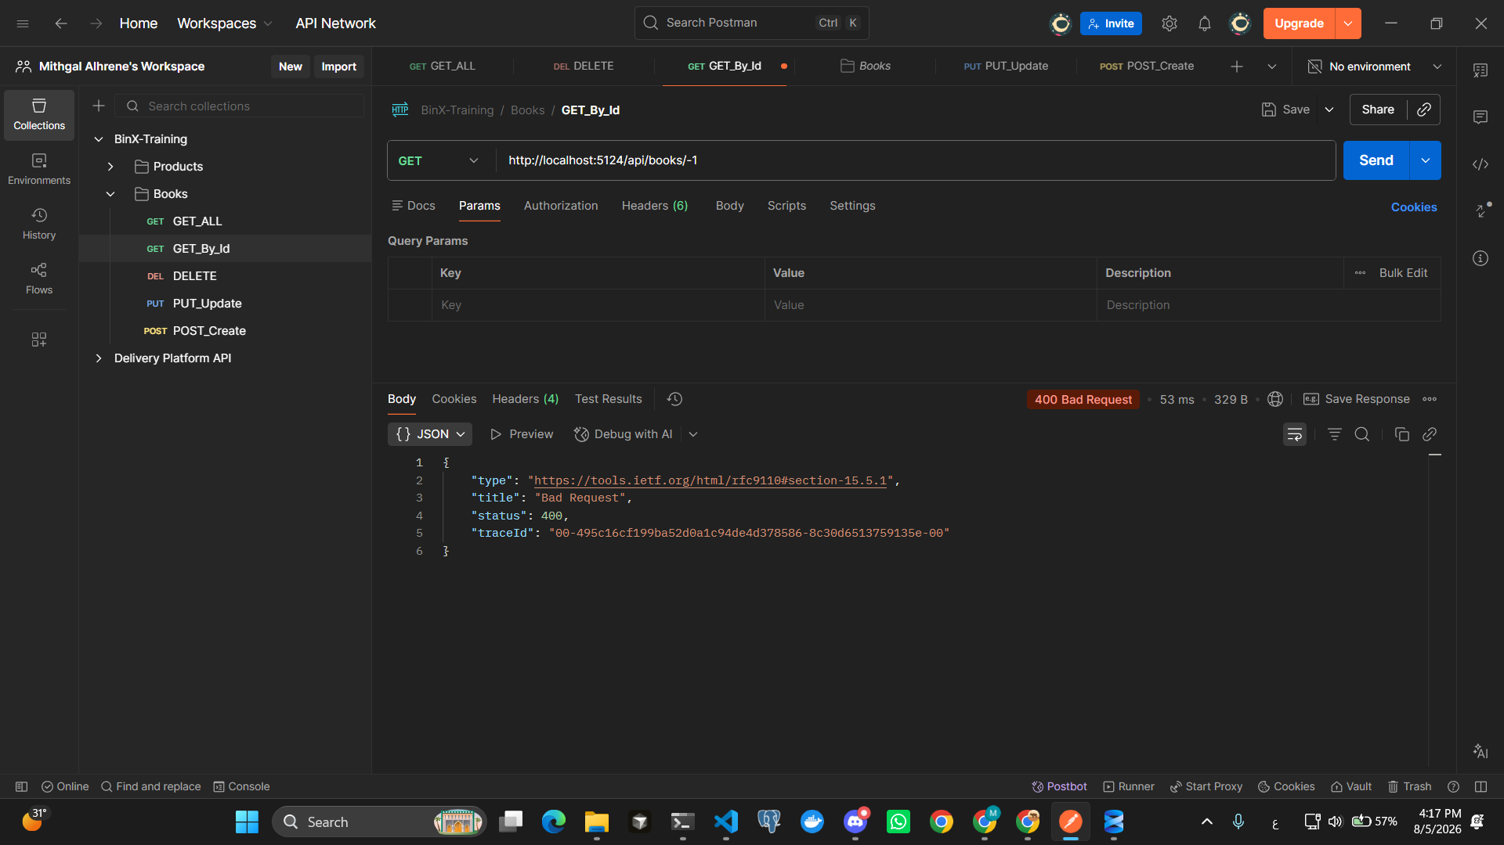

4. GET Non-Existing Book (404 Not Found)
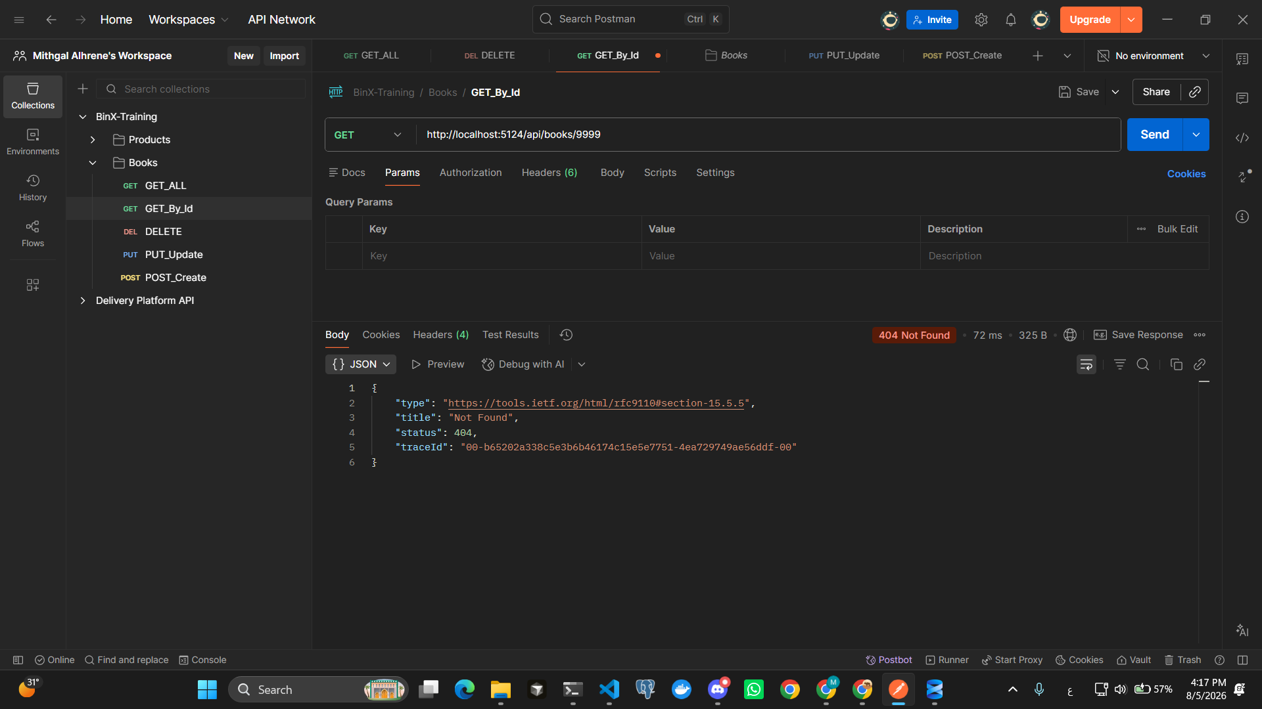

5. POST Create Book (201 Created)
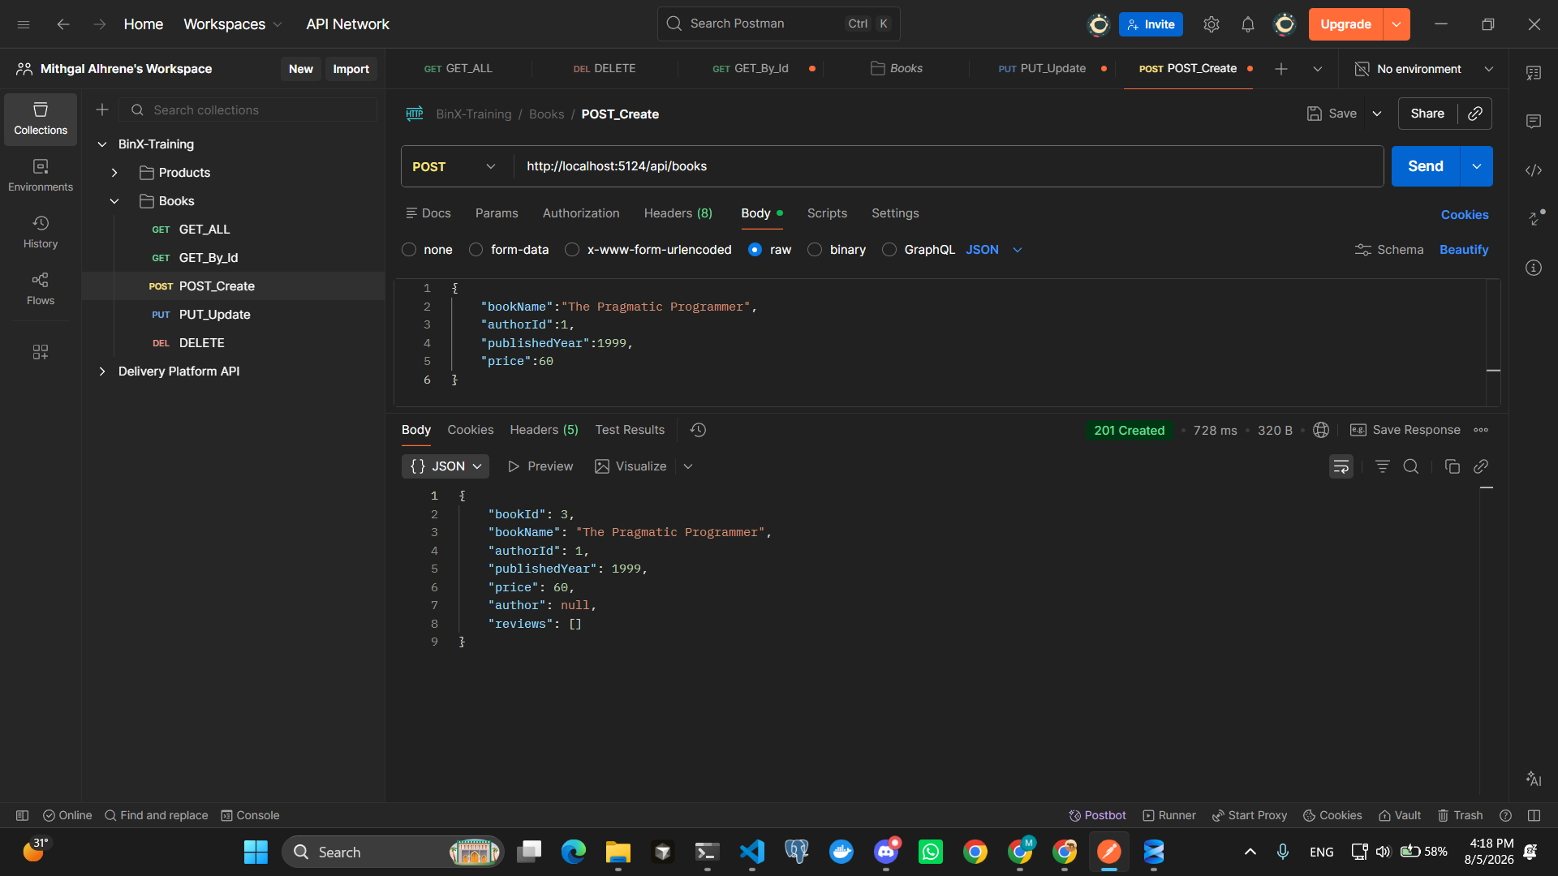

6. GET All Books After Create (Book Added Successfully)
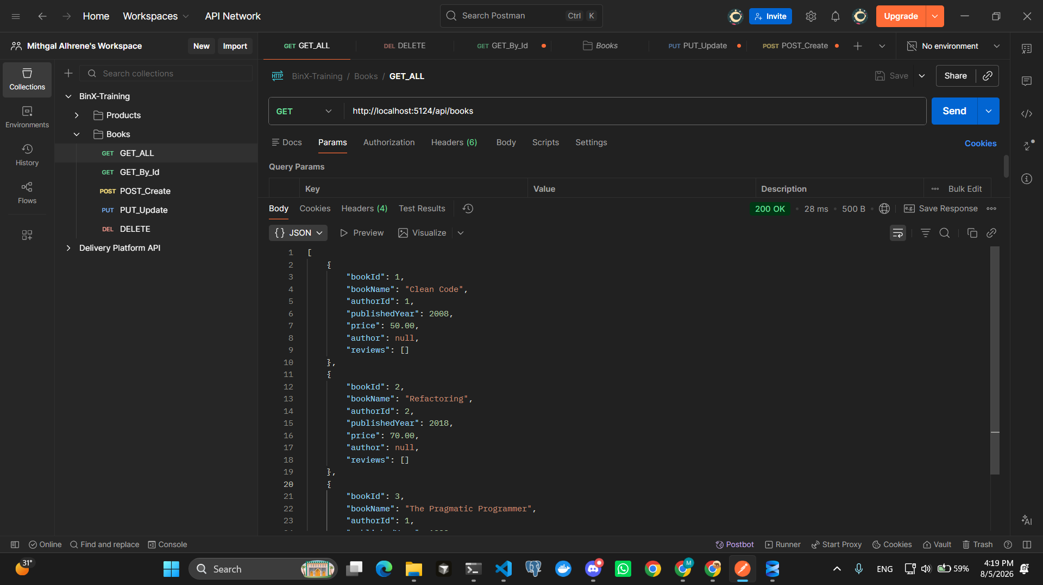

7. POST with Invalid AuthorId (Foreign Key Error)
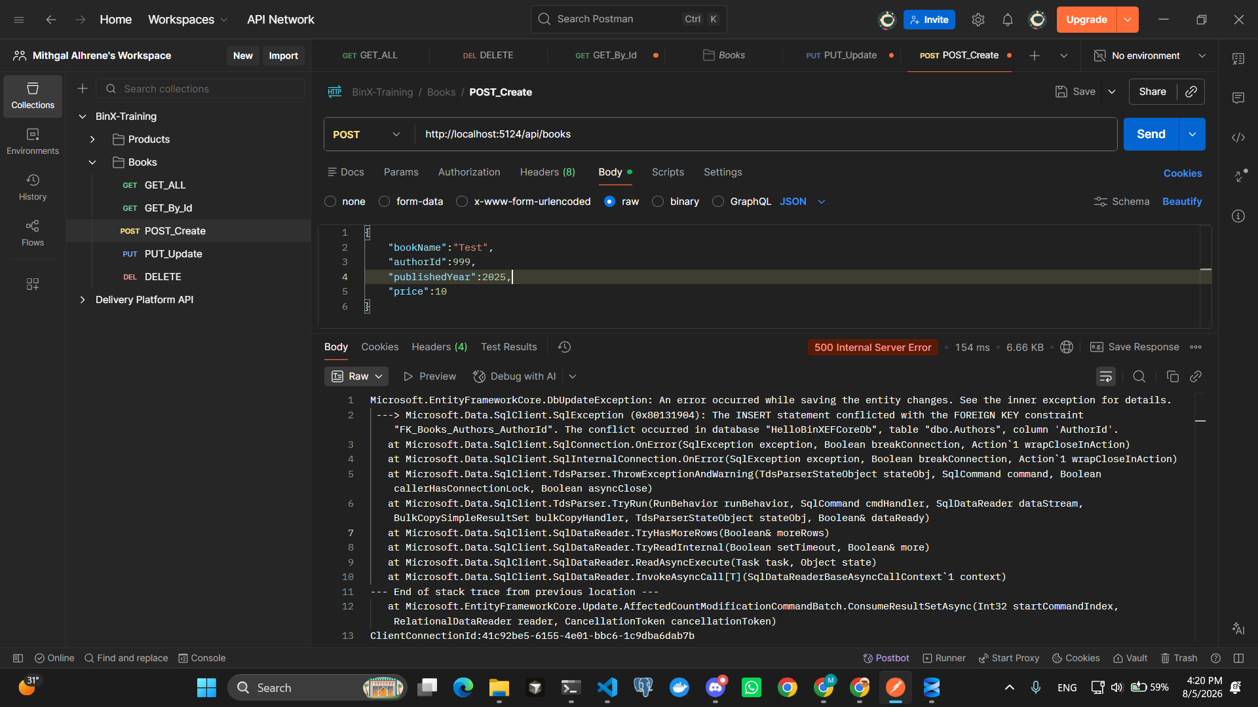

8. PUT Update Book (200 OK)
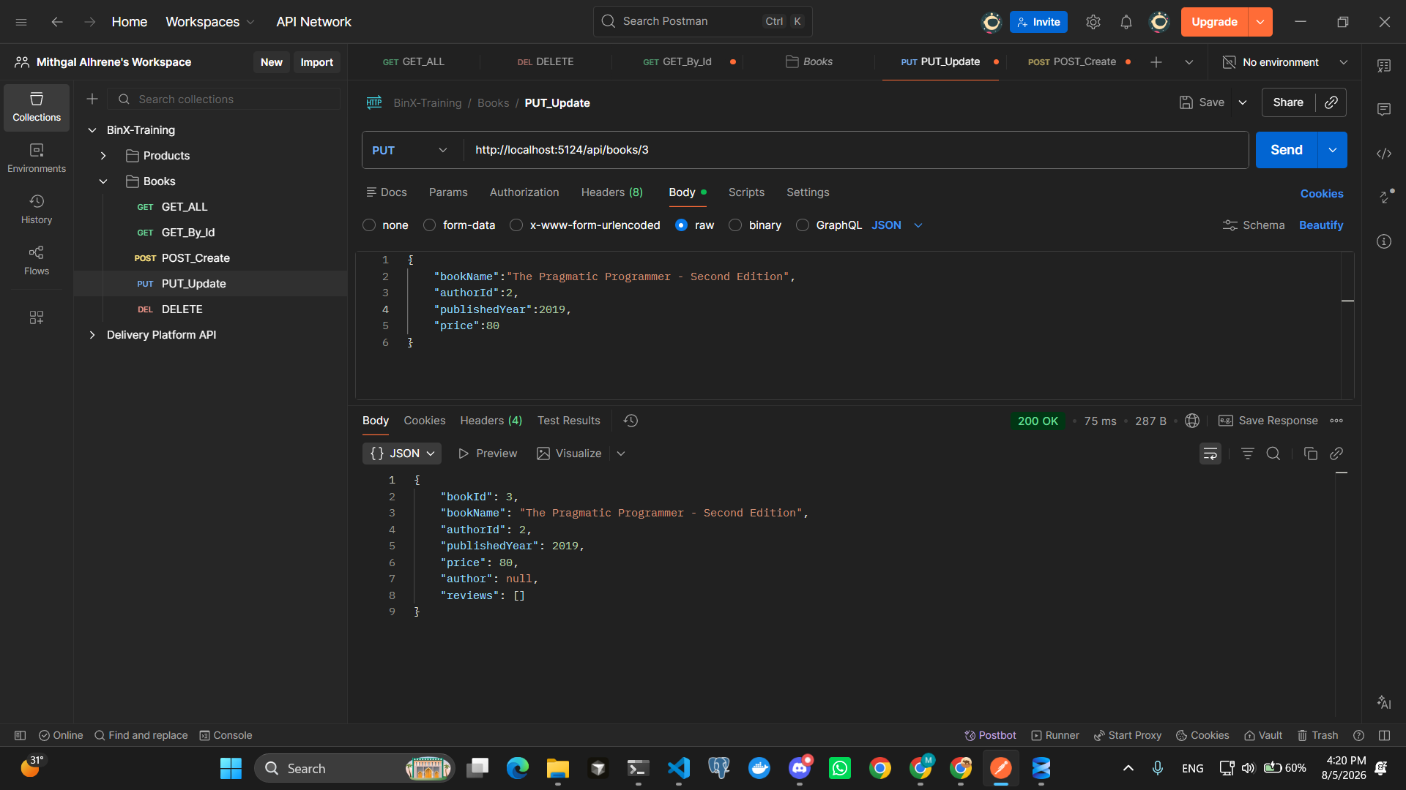

9. PUT Update Non-Existing Book (404 Not Found)
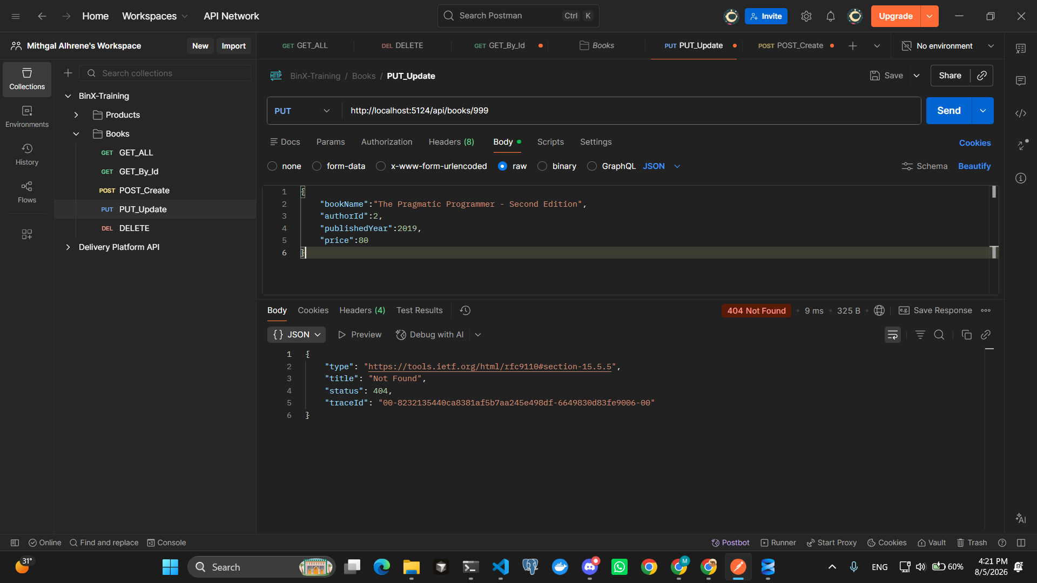

10. DELETE Book (204 No Content)
